

Handwriting and Presentation Policy



St Margaret’s Junior School Handwriting and Presentation Policy

Rationale:
A consistently high standard of presentation and handwriting is promoted across the whole school which all children and staff recognise, understand and follow. For children and teachers this aims to foster a sense of pride and respect in their work. Self-esteem is raised when children are able to communicate meaning accurately.

Presentation across the school:
- All books are named with the title of the book/topic, class, Year group and the child’s name.
- Every piece of work is dated (long date in all subjects except Maths).
- The date should be written on the top line on the left-hand side and underlined in pencil with a ruler. The next line should be missed and an appropriate LQ should be written. This should be underlined KS2.
- In addition to this the subject area being studied should be written in the margin and underlined
- E.g.

Monday 2nd September 2025

LQ – Can I describe the Life Cycle of a frog?

Begin writing here….

- Modelled examples are used to introduce new skills and reinforce expectations.
- Children use guidelines if they are writing on plain paper.
- All drawings and diagrams are drawn in pencil.
- Any straight lines are drawn with a ruler without exception.
- Pencil crayons, not felt pens, are used in exercise books.
- Coloured biros are used for specific reasons by children e.g. self-correcting, editing or peer assessment.
- One single straight line (with a ruler) is used to cross out mistakes or edit writing.
- Books are well kept with no writing or doodling on the outside or inside of covers.
- Children are taught where to start a new piece of work.
- Poor presentation is challenged through verbal feedback and marking.
- Tippex and correction pens are not to be used by children.
- Felt tip pens are not permitted in the children’s books but may be used for specific purposes E.g. creating a poster on paper that will be stuck into the books.
- Children will rule off after the last piece of work ready to begin new work.
- Work should be ruled off at the start of the following lesson, leaving the teacher room to comment on the work.
- Rubbers will be used within reason to correct pencil work. However, where there is excessive use, children who waste time, the Class teacher can ban rubbers.
- Criteria for presentation of work will be discussed prior to commencement of work.
- Each calculation must be clearly numbered with the number in the margin to distinguish it from working figures. Write the short date i.e. 07.06.21
- Children should record in the margin an F (Fluency), R (Reasoning) or P (Problem Solving) to denote the focus for the learning.
- When squared paper is used for Maths, 1 digit is written in each box and a line is left between each calculation.
- In Maths, an eraser can be used at the teacher’s discretion.
- A double margin can be drawn down the centre of the page to save space in maths books.
- When children achieve a pen license BLUE ink must be used only and no biros.

All children to self-assess their work using a purple pen.

Handwriting across the school:
- Children use a continuous cursive handwriting style. This is also modelled by staff when writing on the board/ in their books etc.
- They are encouraged to maintain a correct posture and pencil grip.
- Handwriting is discretely taught, if needed.
- Opportunities for linking phonics and spelling are used.
- Handwriting books are used from when it is developmentally advantageous to do so.
- Additional handwriting sessions are given to those children whose letter formation, joining or speed require improvement.
- Children write in pencil until they achieve their pen license. They can then write in BLUE ink and no biro. Children may lose this privilege if the standard of handwriting decreases. See Appendix 1 for criteria to achieve a pen license.

Getting Ready to Write - Correct posture and pencil grip for handwriting.
- Pupils should be taught to sit correctly at a table, holding a pencil comfortably and correctly.
- Chair and table to be at a comfortable height.
- The table should support the forearm so that it rests lightly on the surface and is parallel to the floor.
- Encourage children to sit up straight and not slouch.
- The height of the chairs should be such that the thighs are horizontal and feet flat on the floor.
- Tables should be free of clutter.
- Rooms should be well lit.
- Left-handed pupils should sit on the left of their partners.
Sit with a straight back not leaning backwards over the chair.

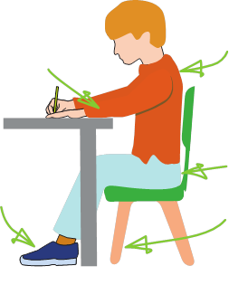
The table reaches to below the elbow.

Seating position

Pull the seat in close to the table.
Keep feet on the floor.

Pencil grip
Children should write with a pencil (or a pen when appropriate) with a rounded nib.
Pencils should be reasonably sharp. A tripod grip is the most efficient way of holding a pencil, pencil grip will be tracked and assessed through Foundation stage, each year assessment of handwriting grip will be passed on to the receiving teacher to ensure that errors in grip are addressed.

For right-handed children
Hold pencil lightly between thumb and forefinger 3 cm away from the point. The paper should be placed to the right slightly tilted to the left. Use the left hand to steady the paper.

The tripod pencil grip
Both right and left-handed children should be encouraged to use the tripod grip which allows the pen/pencil to be held securely whilst allowing controlled movements of the pen/pencil nib.
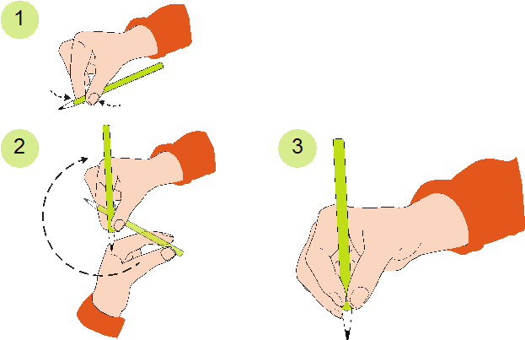
- Grip the pencil with your index finger and thumb with the nib pointing away.
- With your free hand, spin the pencil from underneath.
- Use your middle finger to support the underside of the pencil.

For left-handed Children
Hold the pencil lightly between the thumb and forefinger, resting on the first knuckle of the middle finger; hold about 3 cm from the tip. The hand should be kept below the writing line. The paper should be tilted slightly to the right at about 20/30 degrees. Use the right hand to steady the paper.

NB It is very important that a right-handed child is not seated on the left-hand side of a left-handed child as their elbows will collide.

Specialist pens, pencils, grips, handwriting books and writing slopes are available to support with the development of the tripod grip and handwriting in general, see English Lead/Inclusion Manager.

Specific Progression:

Years 3 and 4
- Children work on securing joins, improving fluency and continuing spelling links.
- Children are expected and taught how to use a ruler to draw lines, including underlining, diagrams, labelling and crossing out.
- Children write in paragraphs around a theme.
- Children are taught to adapt the layout of their written work to fit the intended purpose, i.e. letter presentation, play script, etc.

Years 5 and 6
- Children are expected to use a ruler to draw lines, including underlining, diagrams, labelling and crossing out.
- Teaching of handwriting continues to develop an efficient writing speed and aids spelling.
- Children learn to select the most appropriate presentation style for different writing genres.
- They begin to understand the balance between speed and legibility, which is dependent on the purpose of the writing: the product or the final draft of a piece of writing.

Inclusion:
These expectations apply to the vast majority of children in our school. Occasionally a decision will be made to personalise expectations for a child who has such specific needs that these expectations could be a barrier to their progress (e.g. a child with physical difficulties writing). Difficulties are addressed through appropriate interventions or specific equipment.

Modelling expectations:
Children must be taught the expectations. Put the date on the right and underline, doesn’t mean that they know how to space their writing, or not write their letters really big to fill the space.
At the beginning of the academic year, you should plan to spend time teaching the children your expectations. Be meticulous with detail so that the children are not only clear, they have a best piece of presented work to refer back to.

NB- presentation is an area for improvement. We must continue to evidence our work on this through the children’s books without exception.

Hints & Tips:
- Photocopy good examples of children’s work to put on display to model to the children expectations or examples of where the children have done it well.
- Have a large modelled example on your working wall/ around the room.
- Have smaller laminated examples on children’s desks that replicate their books.
- Put coloured dots in their books to show where to begin.
- Draw numbers in their books so 1 digit in each box.
- When completing calculations, create a model for the children to demonstrate how to set the work out in their books.
- When sticking into their books, clearly model how to glue and position their work. Sheets should only be folded once.
- If cutting out- show the children how to hold their scissors and the paper and cut slowly.
- Ensure that any writing modelled on the board/flipchart paper/ in books uses cursive script.
- Use of pencil grips or triangular pencils may support pupils.
- Focus in on pupils who find handwriting difficult and spend time ascertaining what their difficulties are. Work on particular letter types with them and then move on to others once they have mastered those. Ensure that pupils are not left to continually make the same mistakes with their letter formation/handwriting as it will be much harder to rectify later.
- Trial the use of different types of pencil grips, writing slopes, A4 handwriting books, move and sit cushions if you feel they would support pupils – these can be requested from the Inclusion Manager.
- When pupils are particularly struggling with handwriting, raise them for support through interventions.
- During handwriting sessions, use websites such as: https://www.ictgames.com/mobilePage/writingRepeater/ to show pupils how to form and join certain letters, enabling staff to be free to support pupils.

Celebration and Motivation:
All members of staff ensure that presentation and handwriting is promoted by:
  - Celebrating work of a high standard, including homework, in whole class situations.
  - Ensuring good presentation and handwriting is rewarded in line with the whole school behaviour policy.
  - Sharing good work in whole school assemblies.
  - Displaying written work with annotated comments recognising achievement.
  - Using joined legible and consistently formed handwriting on boards, in books, on flip charts and displays.
  - Providing modelled examples and reviewing expectations with children.

Homework:
Parents are encouraged to support their children to produce quality work following the policy guidelines. Children are expected to take the same care with homework as they do in their class books.

Monitoring:
Presentation is monitored by the Senior Leadership Team on a regular basis through work scrutiny, lesson observations and pupil interviews.

Feedback will be shared with the class teacher and at Leadership meetings. This will ensure that the policy leads to good practice.

Appendix 1.

Criteria for achieving a pen license:

- All writing must start at the margin.

- All dates and LQs must be underlined with a ruler and pencil.

- All mistakes must be crossed through with a pencil, ruler and a single straight line.

- All letters should be sitting on/under the line as appropriate for that letter/case.

- There should be a clear distinction in size for the capitals and lower-case letters.

- Lower case and capital letters should be of consistent sizing and able to be read.

- Letter formation and joining should be correct.

- Handwriting should be consistent across all subjects and a variety of pieces of work.

- Handwriting must be seen by Mrs Lynch – English Lead, to achieve a pen license

Agreed cursive lettering:
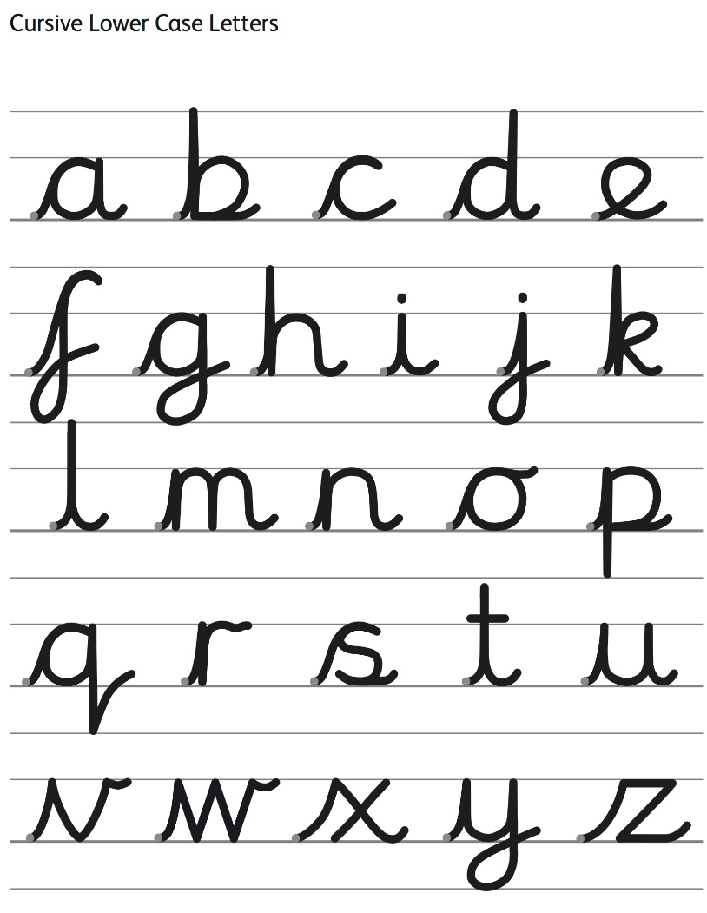
GS writing- Year 6
GDS writing- Year 2

